**Satellite image Classification**

**1. Preprocessing Summary:**

The Satellite image dataset underwent the following preprocessing steps:

* Resizing: Images were resized to 64x64 pixels.
* No data augmentation techniques were applied.

**The test Accuracy without using Active Learning:90.4%**

**2. Active Learning Strategies Comparison:**

**Random Sampling:**

* Random sampling involved randomly selecting instances from the pool without considering the model's uncertainty or prediction confidence. This approach provides a baseline performance for comparison.
* training Accuracy: 50%.
* Test Accuracy: 50%.

**Entropy Sampling:**

* Entropy sampling selects instances where the model is most uncertain about the predictions. It calculates the entropy of the predicted probabilities and selects samples with high entropy, indicating higher uncertainty.

training Accuracy: 88.1%.

Test Accuracy: 88.3%.

Entropy sampling aims to actively select instances that are challenging for the model, thereby potentially improving model performance over random sampling.

**Uncertainty Sampling:**

* Uncertainty sampling selects instances where the model exhibits the highest uncertainty in predictions. It considers various uncertainty measures such as least confidence, margin, and entropy to select samples that the model is least confident about.
* training Accuracy: 90.79%.
* Test Accuracy: 90.94%.

Uncertainty sampling aims to focus on the instances where the model is least certain, with the expectation that acquiring labels for these instances will lead to better model generalization.

**Disagreement Sampling:**

* Disagreement sampling selects instances where multiple models in an ensemble disagree on predictions. It leverages the disagreement among multiple models to identify challenging instances for which the models have different predictions.
* training Accuracy: 93.67%.
* Test Accuracy: 93.52%.

Disagreement sampling aims to exploit the diversity of multiple models to identify ambiguous or challenging instances, potentially improving the robustness of the model.

**3. Comparison Visualization:**

* Based on these results, it appears that both Uncertainty Sampling and Query by Disagreement achieved the highest accuracy of more than 90%. Therefore, either of these two strategies could be considered the better choice for the Satellite image dataset among the ones tested.

**Cifar-10**

**1. Preprocessing Summary:**

The CIFAR-10 dataset underwent the following preprocessing steps:

* Resizing: Images were resized to 32x32 pixels.
* Normalization: Pixel values were normalized to the range [0, 1].
* No data augmentation techniques were applied.

**The test Accuracy without using Active Learning:67.57%**

**2. Active Learning Strategies Comparison:**

**Random Sampling:**

* Random sampling involved randomly selecting instances from the pool without considering the model's uncertainty or prediction confidence. This approach provides a baseline performance for comparison.
* training Accuracy: 50%.
* Test Accuracy: 50%.

**Entropy Sampling:**

* Entropy sampling selects instances where the model is most uncertain about the predictions. It calculates the entropy of the predicted probabilities and selects samples with high entropy, indicating higher uncertainty.

training Accuracy: 71.78%.

Test Accuracy: 69.41%.

Entropy sampling aims to actively select instances that are challenging for the model, thereby potentially improving model performance over random sampling.

**Uncertainty Sampling:**

* Uncertainty sampling selects instances where the model exhibits the highest uncertainty in predictions. It considers various uncertainty measures such as least confidence, margin, and entropy to select samples that the model is least confident about.
* training Accuracy: 72.65%.
* Test Accuracy: 71.55%.

Uncertainty sampling aims to focus on the instances where the model is least certain, with the expectation that acquiring labels for these instances will lead to better model generalization.

**Disagreement Sampling:**

* Disagreement sampling selects instances where multiple models in an ensemble disagree on predictions. It leverages the disagreement among multiple models to identify challenging instances for which the models have different predictions.
* training Accuracy: 73.83%.
* Test Accuracy: 70.58%.

Disagreement sampling aims to exploit the diversity of multiple models to identify ambiguous or challenging instances, potentially improving the robustness of the model.

**3. Comparison Visualization:**

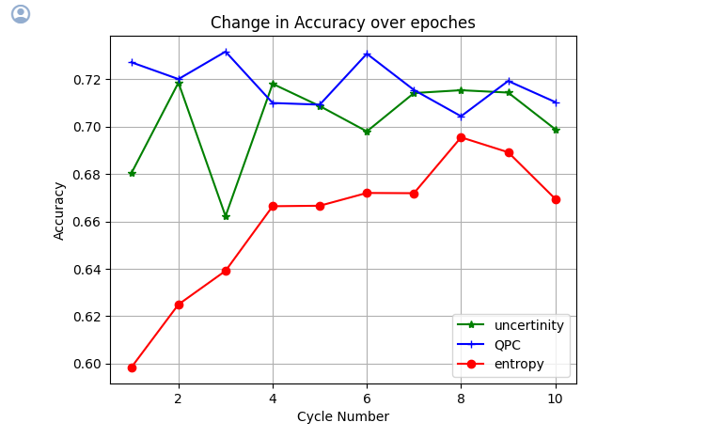

* Based on these results, it appears that both Uncertainty Sampling and Query by Disagreement achieved the highest accuracy of 70%. Therefore, either of these two strategies could be considered the better choice for the CIFAR-10 dataset among the ones tested.